Activity 1.2.1 Design Process

Introduction
All humans have the ability to design and solve problems. Design is a creative process that allows people to solve problems, realize dreams, and implement ideas to improve lives. Good designs turn ideas into products and systems to meet the needs of the consumer. Engineers and designers use a systematic method of solving problems called the design process. Because there is never just one solution to a problem, the process of design is iterative – that means that potential solutions are continually tested and improved upon until the best possible solution under current circumstances is reached. As new technology is available, there may be new problems that arise and new solutions that become possible. Imagine if we were still driving the first practical gasoline-powered automobile invented, an open three-wheeled vehicle? Innovations to the automobile have occurred because new technology has become available and modern consumers demand more sophisticated systems to meet their needs and desires.

Equipment
- Gateway notebook
- Computer with Internet access
- Headphones to plug into the computer

Procedure
In this activity you will learn about the steps in the Design Process and apply them to a challenge completed by the PBS Kids Design Squad team.

- Complete the Design Process Notes page of the handout attached as your teacher explains the PLTW Design Process using the Design Process presentation.
- Log in to a computer with headphones and listen to one of the Design Squad videos from Season 2. Use this URL: http://pbskids.org/designsquad/, then choose from one of the design challenges that the Design Squad completed. You can choose from: Cardboard Furniture, PVC Kayak, Green Machines, Gravity Bikes, Water Dancing, Backyard Thrill Ride, Big Bugs, Aquatic Robotics, Band Cam, No Crying in Baseball, Hockey Net Target, Off-Road Go-Karts 1, and Off-Road Go-Karts 2.
- Complete the Design Squad area of the handout after watching the video on the computer.
- Complete the conclusion questions and turn in the activity to your instructor.

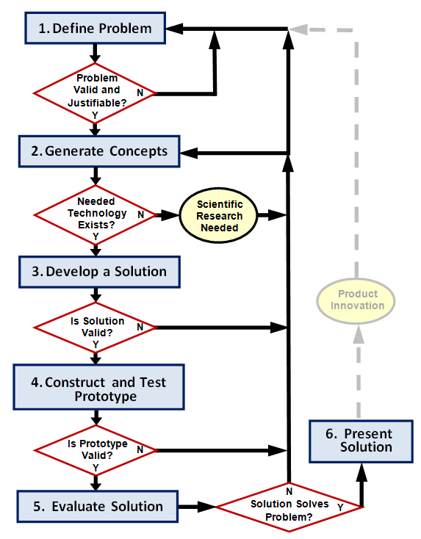
Design Process Notes
- What is design?

- What is the design process?

Design Process Step | Definition | Example
Define Problem

Generate Concepts

Develop a Solution

Construct and Test Prototype

Evaluate Solution

Present Solution

Design Squad
- Which video did you watch?

- In your own words, describe the problem/challenge that was given to the teams.

- List the criteria and constraints that were given to the teams.

- Complete the table below, describing what each team did at each stage of the design process.
Green Team Purple Team
Define Problem
Generate Concepts

Develop a Solution

Construct and Test Prototype

Evaluate Solution

Present Solution

Conclusion Questions
- Why do we use a design process?

- Which stage of the design process do you think is most important? Why?

- Teamwork is an important part of completing projects and design challenges. If you were working on a team, how would you contribute to the team?

- Which team won the challenge that you viewed? Based on what you saw, how would you explain their success?

