Project 1.2.3 Furniture Design

Introduction
Now that we know the process needed for an engineer or designer to create an invention or innovation, let’s practice the process by designing a piece of furniture. Can you imagine if that was all of the information that you were given for an assignment? Engineers must understand the problem that they need to solve as well as the criteria and constraints that they must meet. Therefore, they use a design brief to identify the problem, the expectations, and the constraints. The design brief is necessary in order to complete the first step (Define the Problem) in the design process. Once the problem is defined, the engineering team can continue with the design process knowing that they may have to go back to the beginning and redefine the problem at any point during the process. Remember, the design process is never finished; we can always innovate a product to make improvements or to better meet the needs of today.

You and a partner will design a table or chair with no more than 6 pieces (not including braces if necessary). Later in the Design and Modeling™ unit, you will continue the design process by modeling the piece of furniture using 3D modeling software. It is important that you consider ergonomics in the development of your table or chair. Ergonomics means fitting a product to the user. For example, you and your partner will need to decide whether your chair is for an adult or child, whether it will be used when you sit at a desk, eat a meal, watch TV, play video games, etc.

Equipment
- Gateway notebook
- Isometric graph paper
- Orthographic graph paper
- Computer for Internet research
- Measuring tools, yardstick, meter stick, ruler, tape measure

Procedure
This project will take you through the first three steps of the design process. Make sure that you save your work in your Gateway notebook as you will need to model your table or chair using 3D modeling software later in the Design and Modeling unit.

- One way to Define a Problem is to use a design brief. Complete the Furniture Design Brief page as your teacher explains each section of the design brief. You and your partner can decide what you want to design (table or chair), who will use your piece of furniture (adult or child), and the purpose of the piece of furniture. You must include this information in the design brief. Once you complete the design brief, you have completed the first step of the design process. Turn to the furniture design process solution page and complete the column “How We Completed This Step” next to Define the Problem.
- As you complete each step in the design process, describe your actions on the furniture design process solution chart.
- Now you need to Generate Concepts. What information might you need in order to make your table or chair? Appropriate size? Appropriate materials? How much weight must it hold? What else? During the research step, you may need to use the Internet, look at books, or measure existing tables or chairs. Make sure that you record all of the information that you gather in your Gateway notebook.
- The next step is to Develop A Solution. Your teacher will provide you with graph paper for sketching your ideas. Both you and your partner should each sketch three different ideas and annotate (put notes on) your sketch where appropriate. Overall dimensions are important to include on your sketches.
- Use a matrix to decide which of the six designs (three from you and three from your partner) you will develop further. A decision making matrix helps you to evaluate whether you have met the criteria with each of your designs and which design best meets the goal. Once you have evaluated the designs, you should have selected the best design because it will have the highest number in the total box of the matrix.
- Complete the furniture design process solution chart.
- Complete the conclusion questions and turn in your project to your instructor.

Conclusion
- What was the most difficult part of the design process? Why?

- Why did you and your partner choose the solution you did?

- What personality traits do you find in a good partner?

4. Were you a good partner? Why or why not?

Furniture Design Brief

Client:
Designer:
Problem Statement:
Design Statement:
Constraints:

Deliverables:

- In the criteria boxes list the criteria from your design brief.
- Under the ideas boxes put your 3 ideas and your partners 3 ideas – label the sketches A, B, C, D, E, and F.
- Evaluate the design idea for each criteria. For a yes or no response to the criteria, use 1 if the answer is no, 2 if the answer is yes. When assessing a criteria, use the scale between 1 and 4, 1 -2 means it almost or definitely does not meet this criteria, 3 - 4 means it almost or definitely is the best possible solution to the problem for this specific need.
- When you finish evaluating your sketches add the numbers across and put your answer in the Total column.
- The design with the highest total is your Best Solution.

 | Criteria
Ideas |  |  |  |  |  |  | Totals
A
Designed by:

B
Designed by:

C
Designed by:

D
Designed by:

E
Designed by:

F
Designed by:

My Design Process Solution

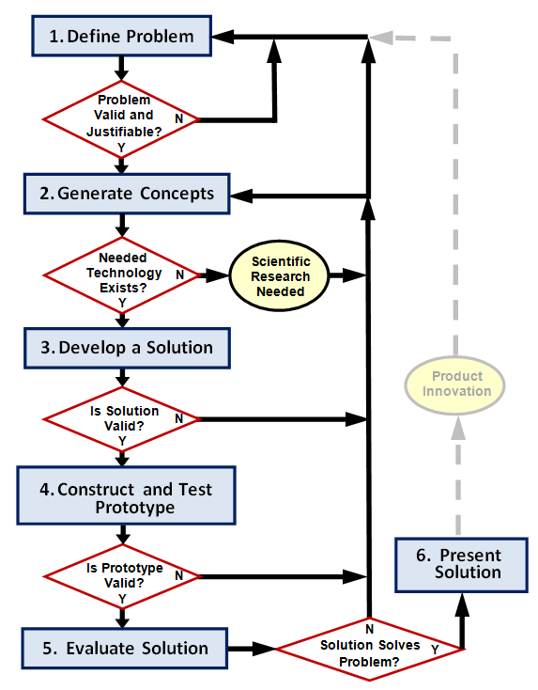

Design Process Step | Definition | Student Work at This Step
Define Problem

Generate Concepts

Develop a Solution

Construct and Test Prototype

Evaluate Solution

Present Solution

