Activity 1.3.2 Standard and Metric Measuring

Introduction
Measurements are seen and used every day. You have probably worked with measurements at home and at school. Measurements can be seen in the form of inches, pounds, hours, cups, meters, grams, liters, etc. Standard or Customary units are usually written with fractions or mixed fractions. Metric or SI (International System of Units) values are written as decimals or mixed decimals.

When measuring length in the customary system, the common tools are rulers, yardsticks, and tape measures; the common units are inches, feet, and yards. It is important that you are able to convert between these. Make sure you show your units.
1 foot (ft) = 12 inches (in.)
1 yard (yd) = 36 inches (in.) = 3 feet (ft)
1 mile (mi) = 5280 feet (ft)

The metric system is the most widely used system of measurement in the world. The United States is the only major country that still has a limited use of this system of measurement. Most U.S. businesses have converted to this system due to the fact that they are competing in a global market that is based on the metric system. The metric system is based on powers of ten. The chart below shows the units of the metric system; meters are used to measure length.

 | Thousands | Hundreds | Tens | Basic unit | Tenths | Hundredths | Thousandths
Prefix  Mnemonic | Kilo  King | Hecto  Henry | Deca  Died | UNIT  Unexpectedly | Deci  Drinking | Centi  Chocolate | Milli  Milk
Equivalency | 0.001 km | 0.01 hm | 0.1 dam | 1 m | 10 dm | 100 cm | 1000 mm
Equivalency | 1 km | 10 hm | 100 dam | 1000 m | 10,000 dm | 100,000 cm | 1,000,000 mm
Abbreviations: Length | km | hm | dam | m (meter) | dm | cm | mm
Mass | kg |  |  | g  (gram) |  |  | mg
Volume | kL |  |  | L  (liter) |  |  | mL

So, for instance,

1 meter = 10 dm = 100 centimeters = 1000 millimeters
1 kilometer = 10 hectometers = 1000 meters

Occasionally you may need to convert from English to Metric units or vice versa. The conversion chart from the Gateway formula sheet is shown below.

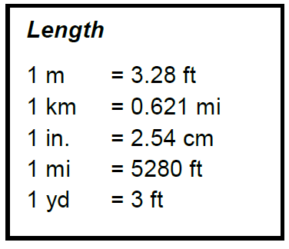

Equipment
- PLTW Gateway notebook
- Measuring devices (ruler, metric ruler, yard stick, meter stick, tape measure)

Procedure
In this activity you will have a chance to practice your Metric and English measuring skills.

- Complete the English and Metric measurement questions in this activity.
- Complete the “Educated Guess” columns of the chart.
- Obtain several measuring devices from your instructor and complete the actual measurement section of the chart.
- Complete the conclusion questions and turn in to your instructor for grading.

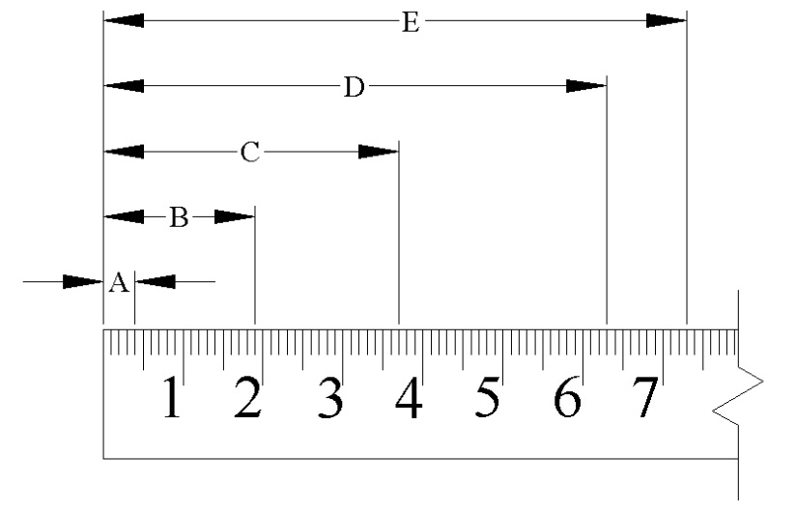  Show work here | - Does the ruler on the left measure in Metric or English units?  - What units would you use?  - What is the distance from the end of the ruler to each point? Don’t forget to include units.  A.  B.  C.  D.  E.  - What is the equivalent of measurement C in inches? Show all work, round answer to nearest tenth.

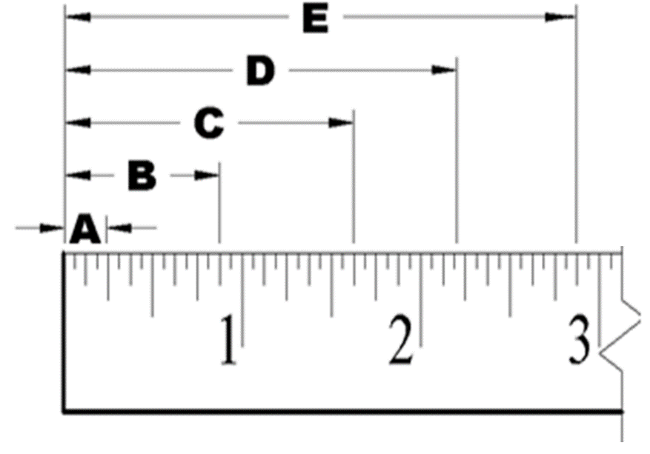 | - Does the ruler on the left measure in Metric or English units?  - What units would you use?  - What is the distance from the end of the ruler to each point? Don’t forget to include units.  A.  B.  Show work here  C.  D.  E.  - What is the equivalent of measurement D in millimeters? Show all work, round answer to nearest tenth.
- Complete the chart below by entering an educated guess of the length of each object in the units provided. Then obtain the proper measuring tool: ruler, metric ruler, yard stick, meter stick, or tape measure. Record the correct measurement in the chart. Don’t forget to include units.

Item | Educated Guess - English | Educated Guess - Metric | Actual English Measurement | Actual Metric Measurement
Notebook | in. | cm
Desk | ft | m
Door | yd | m
Pencil | in. | mm
Cabinet | ft | m
Window | in. | cm
Bulletin Board | yd | m

Conclusion
- Which measurement system is easier for you to use? Why?

- Convert the length of a 2 ft 6 in. desk to each of the following. Show your equations and math.
- ____________ inches (in.)
- ____________ yards (yd)
- ____________ meters (m)
- ____________ centimeters (cm)
- Convert the length of a 4.5 meter bulletin board to each of the following. Show your equations and math.
- ____________ centimeters (cm)

- ____________ decameters (dam)

- ____________ feet (ft)

- ____________ yards (yd)

- Convert 65 miles to kilometers. Show your work and math.

- Convert 1500 meters to miles. Show your equations and math.

- Review your answers to Activity 1.3.1 History of Measurement. Convert each of the following measurements to the indicated units. Show your work and math.
Example: Convert 19 palms to hands
Assume that you measured the width of your lab table as four hands and, again, as 11 palms.
4 hands = 11 palms; therefore, the conversion factor is $\frac{\text{4 hands }}{\text{11 palms}}$
$$\left(\text{19 palm}\right)\left(\frac{\text{4 hands}}{\text{11 palm}}\right)\text{=} \text{6.9 hands}$$

  - Convert 4.5 strides to girth

- Convert 27 cubits to fathoms

- List four ways that you have used measurement in your life and identify the units that you used. For example, I drove 7 miles to get to school today – English units.

