Activity 1.3.3 Precision Measuring

Introduction
The fathom, hand-span, cubit, and other historical methods of measuring were just not accurate enough for engineers and scientists. Many tools have been developed to help take accurate measurements. Micrometers, rulers, and calipers are often used for measuring thickness, internal and external diameters, and depth. Precise measurement with quality tools increases the reliability or accuracy of the data. Precision tools are often used when reverse engineering a part. These measurements provide a better understanding of the interactions of a part so that the engineer can develop a replacement part or improve the existing part. Accurate measurements are important for a successful invention or innovation.

Equipment
- PowerPoint
- LMS

Procedure
In this activity you will learn about precision measuring and how to use a dial caliper to measure thickness, diameter, and depth.

- View the PowerPoint and record notes according to the guide below.
- Complete the Conclusion questions.

Guided Notes for Precision Measurement
- Accuracy is

- Precision means

- List four tools used for measuring length precisely.

- Label the parts of the dial caliper below in the boxes for each part.
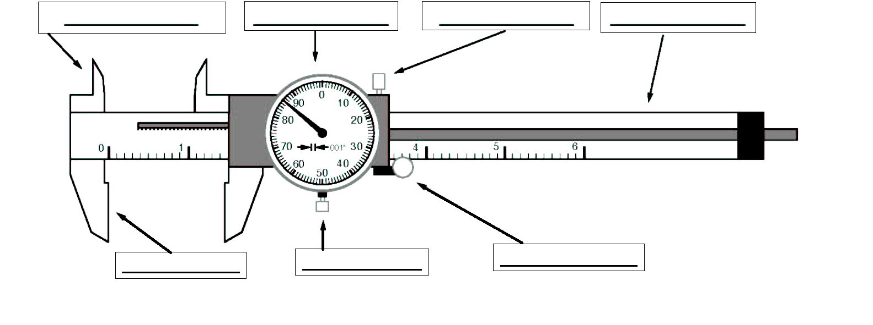
- The dial caliper’s blade graduations are:

- The dial caliper’s dial graduations are:

- One full revolution of the pointer on the dial equals:

- Three steps in reading a dial caliper.

- Dial calipers can measure the following types of measurement.

- Read each dial caliper and record the measurement in the box to the right. (If you are viewing on the computer, you may zoom in, if needed, to see well).

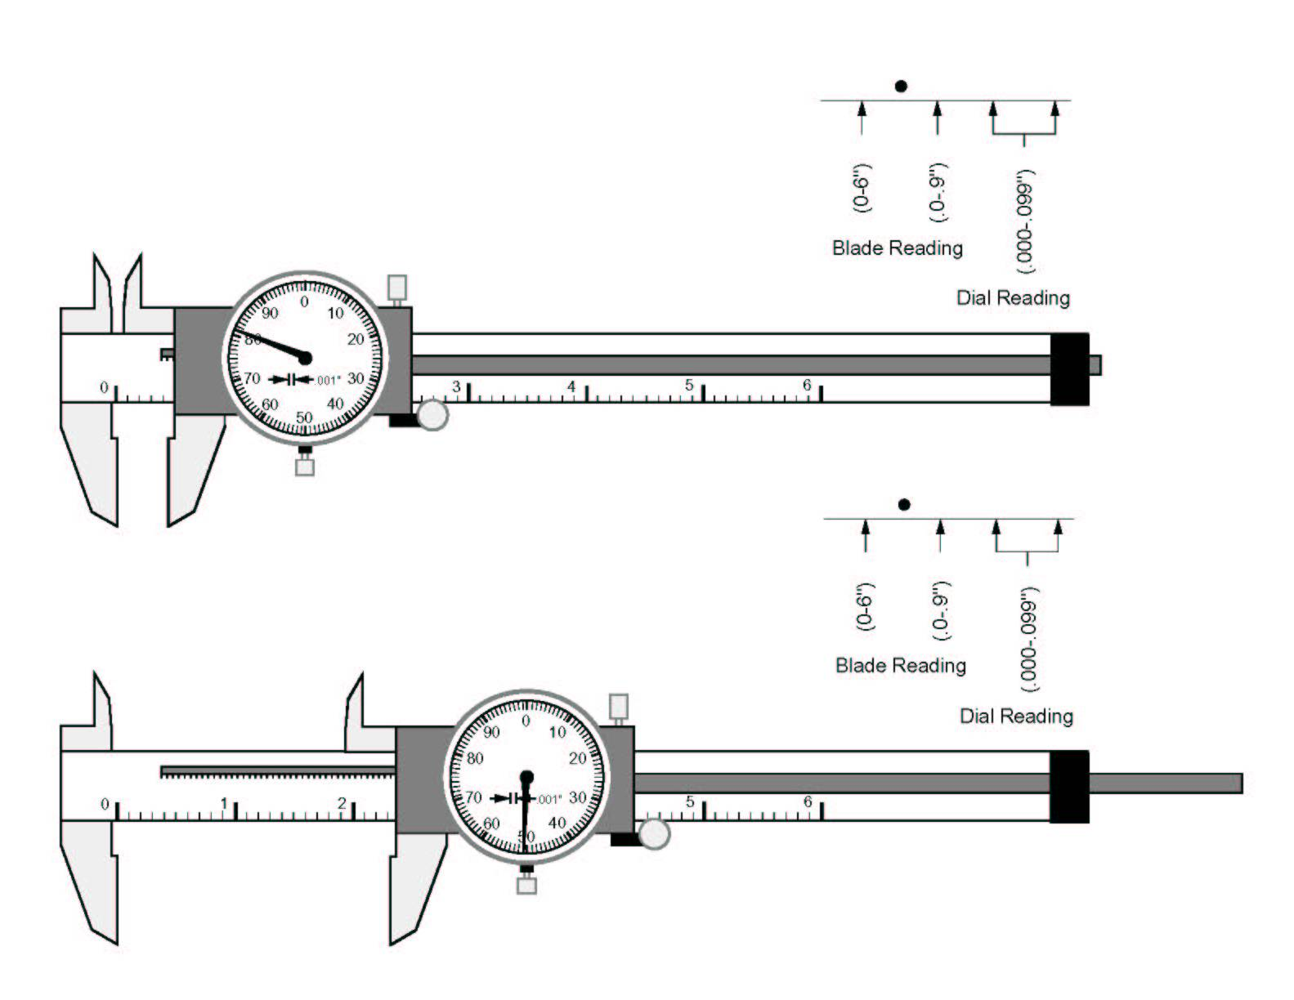
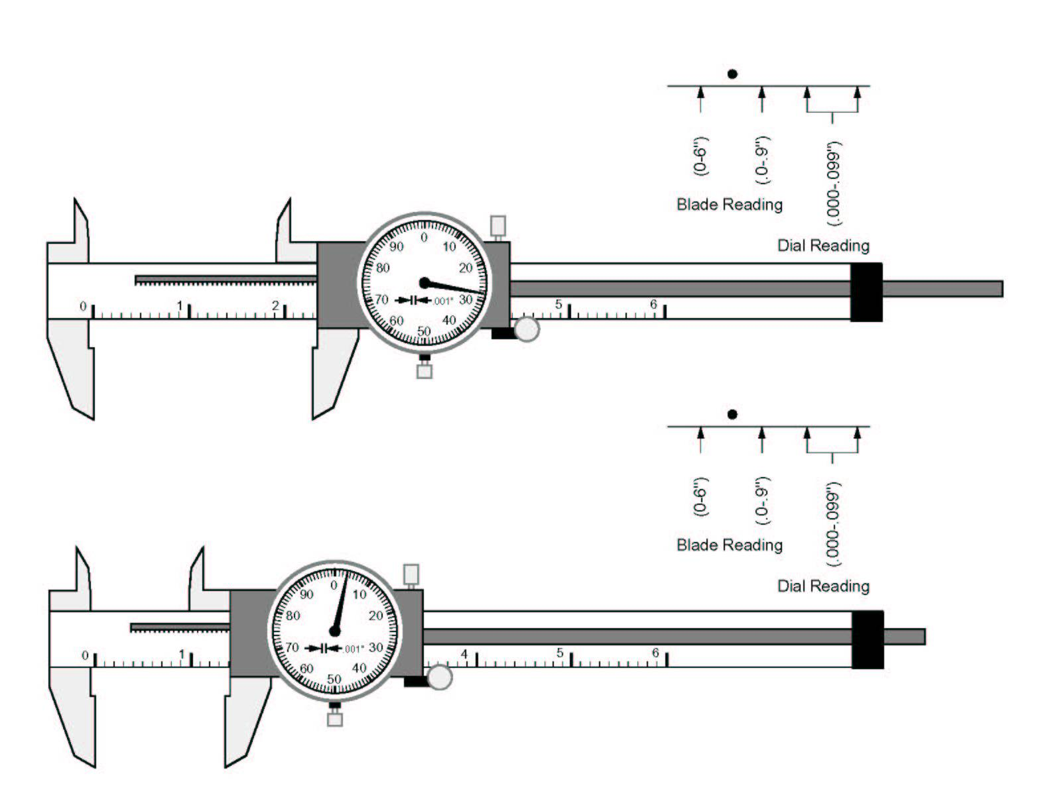

Conclusion

- Dial calipers measure in English units, using inches, but with decimal numbers. Did you find this easier or more difficult than reading an English ruler that uses fractions?

- Reverse engineering is taking apart an object to see how it works in order to duplicate or enhance the object. Why do you think a dial caliper is often the precision measuring tool that is used for reverse engineering an object?

- Describe three places that you think would be important to have a precise measurement. For example, gear ratios on a watch or clock must be exact or you won’t know the correct time.

- Name the four types of measurements that dial calipers can be used for. (Hint: one type is the depth of a hole)

