Activity 1.4.4 Orthographic Projection

Introduction
Did you know that when an invention is sent to the patent office, the patent office must verify that your invention is truly new and unique from other products? In order to do this, the patent office requires explanatory drawings with your application. A simple invention may only require one drawing. More complicated objects or products require orthographic drawings (commonly referred to as multi-view drawings) so that every feature of the invention listed is shown. This is to enable anyone with the appropriate skills to be able to build your invention and test it.

Whether you plan to invent something or whether you are just interested in learning how to make something, a drawing helps you figure out the different parts and how those parts go together. Orthographic drawings enable the reader of the drawings to understand how each part fits and how the final product should look from all views.

Orthographic projection is used to show an object in true size or scale on a flat piece of paper. When we look at an object, we see three dimensions (height, width, depth) all at once. In an orthographic drawing, you will be looking at the object from three different planes. When you look at the front, only two dimensions – height and width – appear. From the top, the two dimensions are width and depth, and from the right side, the height and depth are the dimensions.

Equipment
- PLTW Gateway notebook
- Pencil
- Colored pencils
- Straight edge
- Isometric graph paper
- Orthographic graph paper
- Wooden blocks – 7 cubes, 1 cube with hole, 2 triangles, 1 half round, and 1 cylinder
- Sugar cubes, plastic linking cubes, and other shapes to form various objects for students to draw

Procedure
Orthographic Projection Activity 1:
Match the isometric view with the corresponding orthographic view.

1.________________ | 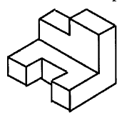 | A.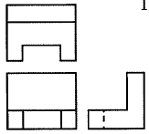
2.________________ | 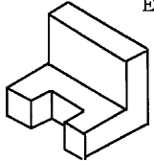 | B.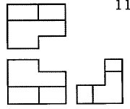
3.________________ | 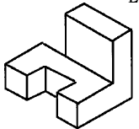 | C.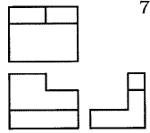
4.________________ | 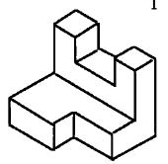 | D.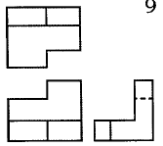
5.________________ | 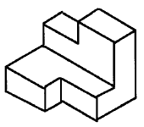 | E.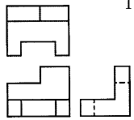
6.________________ | 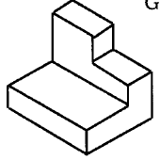 | F.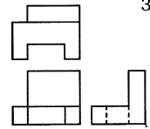
7.________________ | 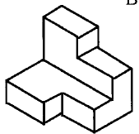 | G.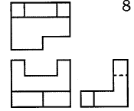

Orthographic Projection Activity 2:
In this part of the activity, you will draw the same block four ways. In each drawing the block is turned to a different position.

- Use colored pencils to color the isometric view. Color the top of the block red, the front of the block green, and the right side of the block blue.
- In each position shown, draw the top, front, and right side views of the block, making sure that the front view is in the bottom left quadrant of the graph paper, the top view is directly above the front view, and the side view is directly to the right.
- The dimensions of the block are given in Figure 1 and are to be used for all of the drawings of the block.
- Each small square represents one inch.
- Notice that the placement of the block in a drawing may fit in the drawing space better than in other views. You will also notice that each drawing may have a different number of hidden lines. Hidden lines are dashed lines used to represent an edge that cannot be seen from a particular view.
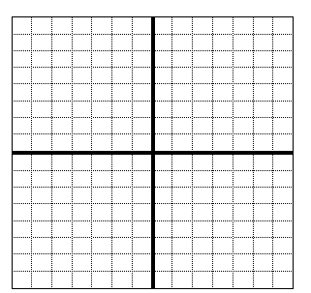
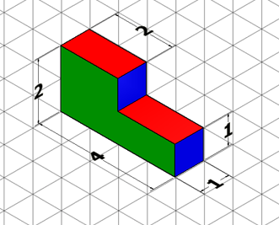  Figure 1 | 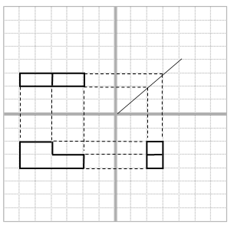
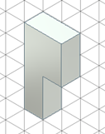
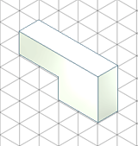
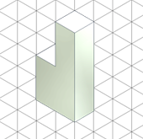
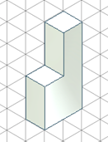

Orthographic Projection Activity 3:
In this part of the activity, you will build an object using a combination of the following shapes – 7 cubes, 1 cube with hole, 2 triangles, 1 half round, and 1 cylinder. You will follow the provided drawings. Finally, you will create your own object using the shapes provided.
- Use the blocks provided to create an object. You will follow the provided drawings. The drawings are orthographic projections, so your model must correctly match each view.
- After building each object, have your teacher or another classmate check your work.

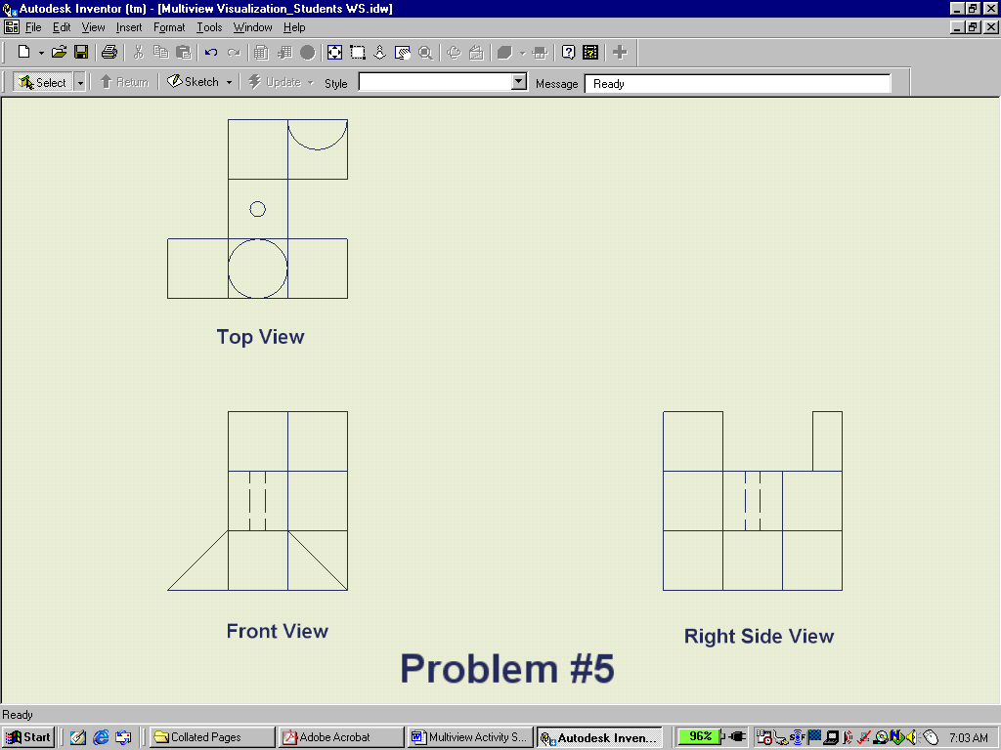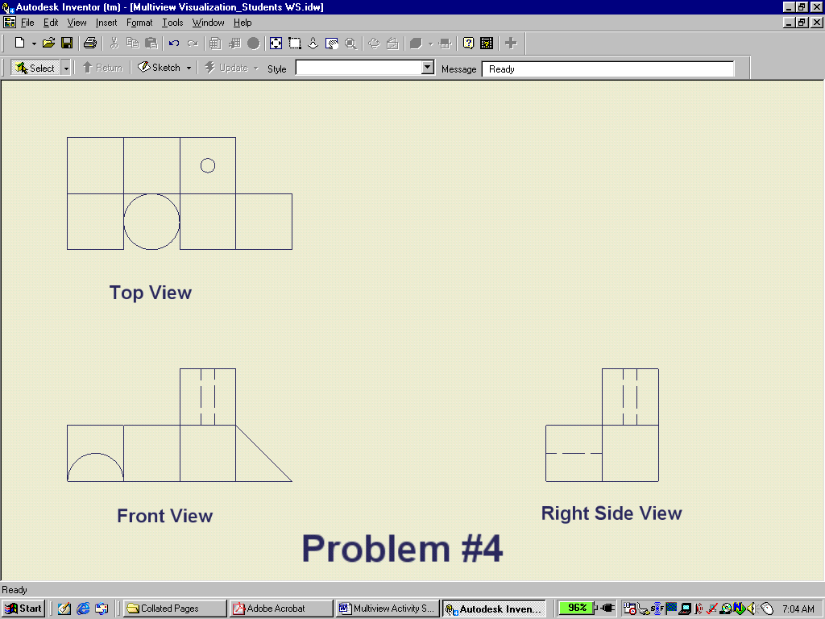
1.
3.
5.
2.
4.

Orthographic Projection Activity 4:
Draw a challenge of your own on the graph paper below. Give your challenge to your teacher or another group to solve.

- Build a model with the blocks.
- Draw the top, front, and right side views of the block on the graph paper. Remember that each small square represents one inch. Make sure you line up the views correctly.
- When the drawing is complete, have your teacher or another classmate try to build the object from your drawing.

Conclusion
- Orthographic drawings are used to express ideas that are more complicated. Explain the purpose of the different views and the importance of view alignment.

- How can you check an orthographic drawing to be sure there are no missing lines?

3. How is an orthographic drawing similar to or different from an isometric drawing?

