Activity 1.4.5 Dimensioning

Introduction
Dimensions are as important as the shapes that you sketch. In order to accurately reproduce a part, the manufacturer must know the proper size and the proper location for all features. This includes the overall height, width, and depth of an object, as well as the size and location of all other features.

There are dozens of rules and guidelines associated with dimensioning. You will learn how to apply just eight of these in order to make your sketches easy for anyone to understand.

Equipment
- PLTW Gateway notebook
- Pencil
- Eraser
- Straight edge

Procedure
In this activity you will begin by following along as your teacher presents information on dimensioning. Then you will apply your knowledge of dimensioning to identify missing dimensions on orthographic drawings. Last, you will practice sketching and dimensioning in orthographic from an isometric sketch. Make sure to follow the dimensioning guidelines.

- Why is it necessary to dimension a sketch?

- What dimensions are needed to fully describe a sketch?

- Label the linetypes in the diagram below:

- When using ¼ in. graph paper, each square equals ¼ in. or .25 in. How many squares are in:
- 1 in. = _________ squares
- 2 in. = _________ squares
- 2 ¾ in. = _______ squares
- 1 ¼ in. = _______ squares
- 4 ½ in. = _______ squares

- Now convert number of squares to a linear measurement. Again, each square equals ¼ in. or .25 in.
- 7 squares = ___________ inches
- 12 squares = __________ inches
- 3 squares = ___________ inches
- 9 squares = ___________ inches
- 22 squares = ___________ inches

- Dimension the following sketch.
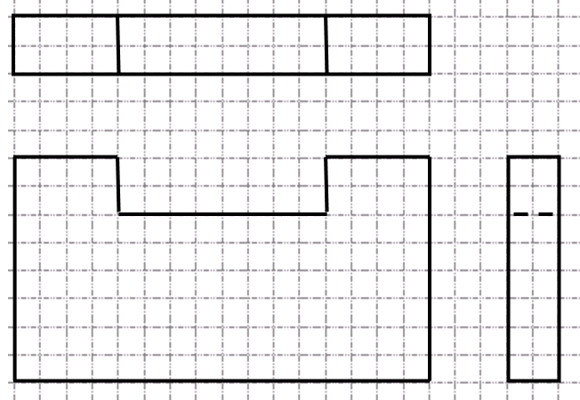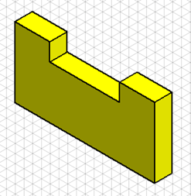Each square on the graph equals ¼ in.

- Dimensions must fully describe an object so that someone else can reproduce it. Fill in the missing dimensions on the sketch below. Each square on the graph represents ¼ in. Be careful not to over-dimension. Each feature should be dimensioned for size and location only once.
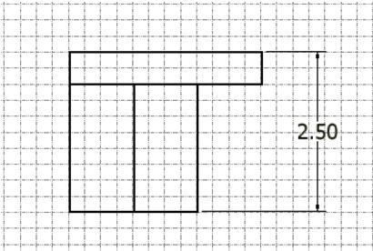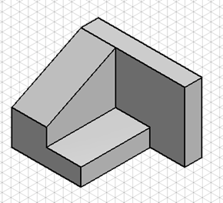
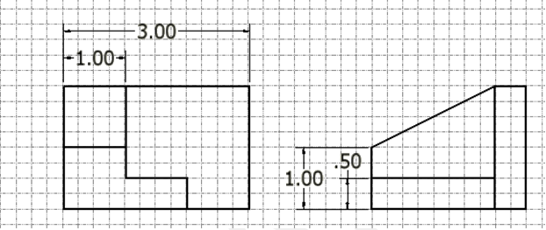

- Follow along as your teacher discusses the presentation on dimensioning guidelines. List the rules or guidelines below.
- Rule 1:
- Rule 2:
- Rule 3:
- Rule 4:
- Rule 5:
- Rule 6:
- Rule 7:
- Rule 8:
- You will create orthographic drawings of objects and dimension them from the isometric sketches in both drawings below. Make sure you place the front view in the lower left corner, the top view directly above the front view in the upper left corner, and the right side view to the right of the front view in the lower right corner. Line up your sketches both horizontally and vertically. Add all of the dimensions necessary using the scale 1 square = ¼ in. Your dimension lines should have arrows at the end, and extension lines should not touch the object line.

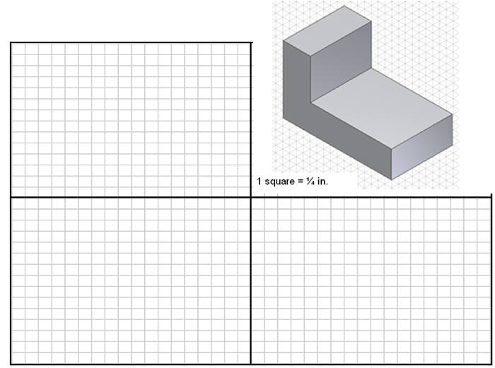
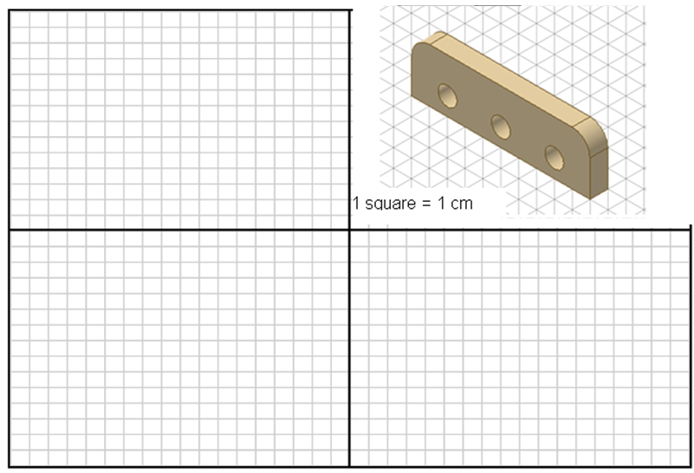
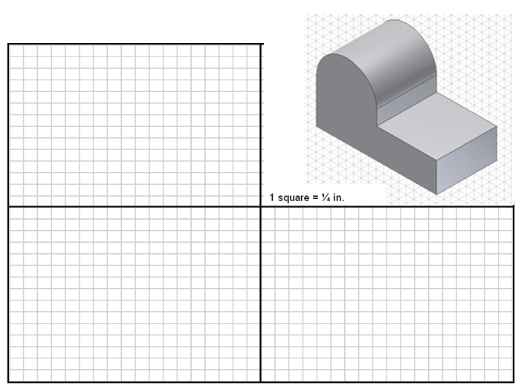
Conclusion
- What is the difference between a size dimension and a location dimension?

- Why is it necessary for engineers, designers, and technologists to make sure that their drawings are fully dimensioned?

- Why is the placement of your dimension important?

- What is meant by over-dimensioning a sketch?

